Esther 2:7And he brought up H539[(H8802)] Hadassah H1919, that [is], Esther H635, his uncle's H1730 daughter H1323: for she had neither father H1 nor mother H517, and the maid H5291 [was] fair H3303 H8389 and beautiful H2896 H4758; whom Mordecai H4782, when her father H1 and mother H517 were dead H4194, took H3947[(H8804)] for his own daughter H1323.

Hadassah is the feminine of H1918 (myrtle)

Search results for "H1918"
Neh 8:15 | And that they should publish and proclaim in all their cities, and in Jerusalem, saying, Go forth unto the mount, and fetch olive branches, and pine branches, and myrtleH1918 branches, and palm branches, and branches of thick trees, to make booths, as it is written.
Isa 41:19 | I will plant in the wilderness the cedar, the shittah tree, and the myrtleH1918, and the oil tree; I will set in the desert the fir tree, and the pine, and the box tree together:
Isa 55:13 | Instead of the thorn shall come up the fir tree, and instead of the brier shall come up the myrtle treeH1918: and it shall be to the LORD for a name, for an everlasting sign that shall not be cut off.
Zec 1:8 | I saw by night, and behold a man riding upon a red horse, and he stood among the myrtle treesH1918 that were in the bottom; and behind him were there red horses, speckled, and white.
Zec 1:10 | And the man that stood among the myrtle treesH1918 answered and said, These are they whom the LORD hath sent to walk to and fro through the earth.
Zec 1:11 | And they answered the angel of the LORD that stood among the myrtle treesH1918, and said, We have walked to and fro through the earth, and, behold, all the earth sitteth still, and is at rest.

In Zechariah, the myrtle is symbolic of Israel.

According to research the myrtle branches are on of the four species used to construct the temporary huts (booths) for the Sukkot festival (feast of tabernacles, feast of booths, memorial of the 40 year wandering).

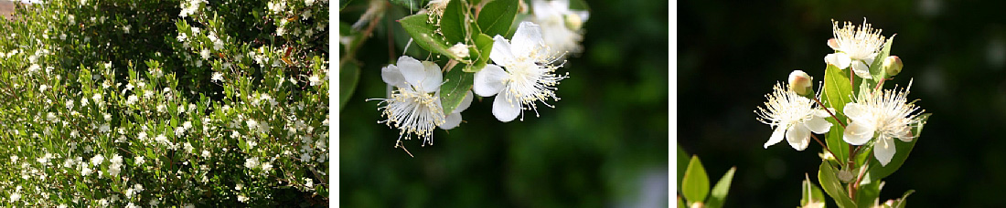
“The myrtle grows wild in the north of Israel – the Carmel, the Galilee and the Golan Heights. Currently there are 49 known sites where wild myrtles grow in Israel, most of which are outside of the national nature reserves. Due to the yearly over-harvesting of myrtle branches in the weeks before Sukkot, the wild myrtle is inכ danger of extinction and has been placed on Israel’s Red List of endangered plant species. Cultivated myrtle varieties are grown commercially not only for the Sukkot “four species” market, but also for sale as ornamental plants in gardens and as protective hedges along roadsides. There is serious concern that the hybridization of the cultivated strain with the wild strain may lead to the complete disappearance of the wild myrtle.” - https://www.neot-kedumim.org.il/index-plant-of-the-month/the-myrtle/

